**Introduction:**

**For best practice refer below links,**

[**https://www.toolsqa.com/protractor-tutorial/**](https://www.toolsqa.com/protractor-tutorial/)

[**https://www.protractortest.org/#/api**](https://www.protractortest.org/%23/api)

**What is protractor?**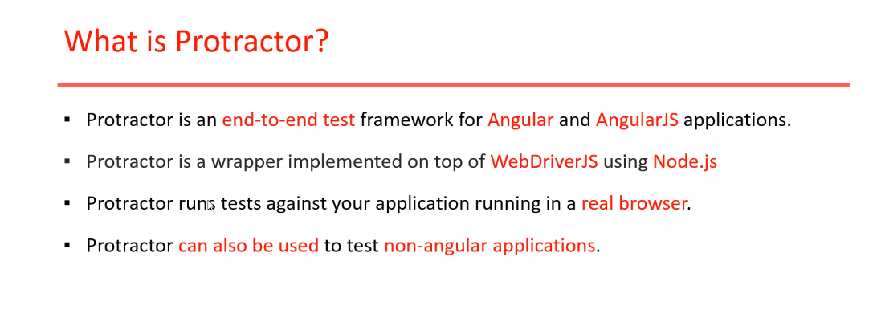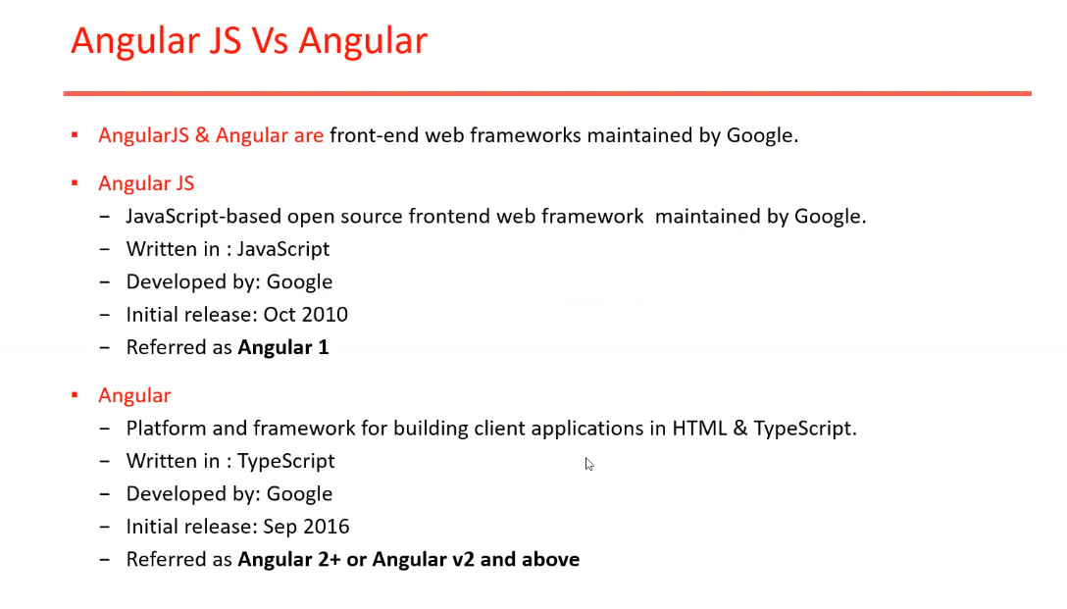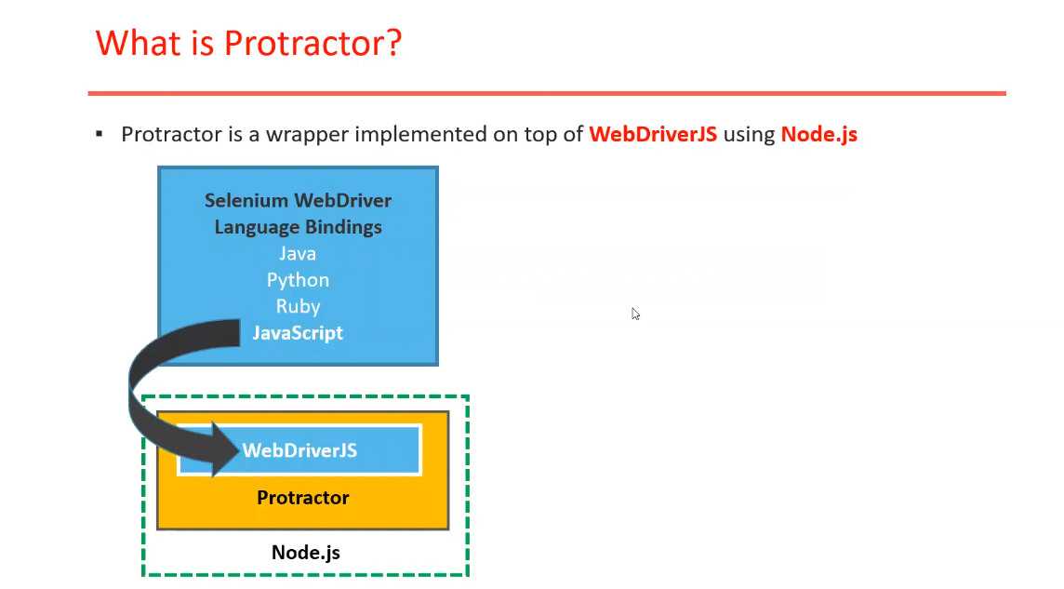

**Why we need protractor? 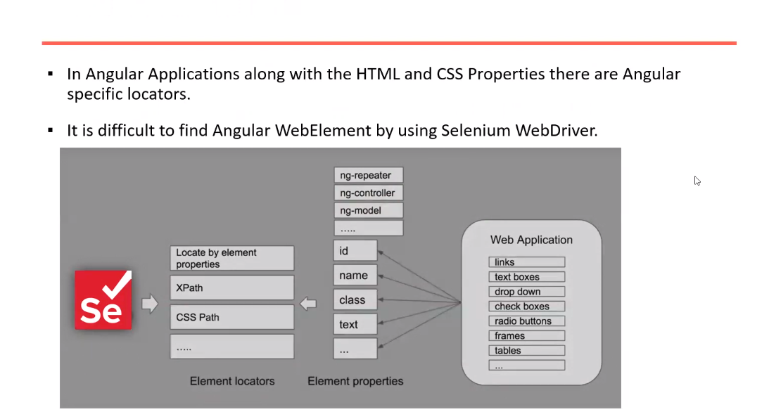 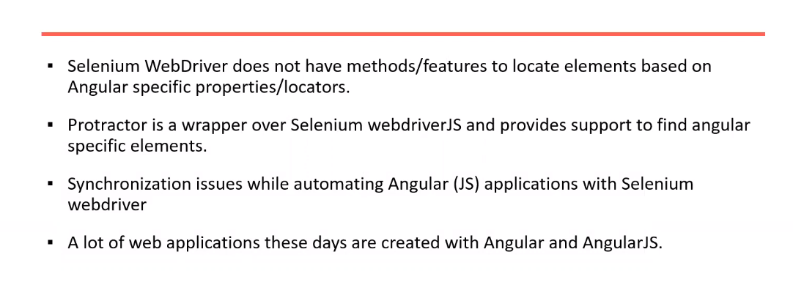 How protractor works? 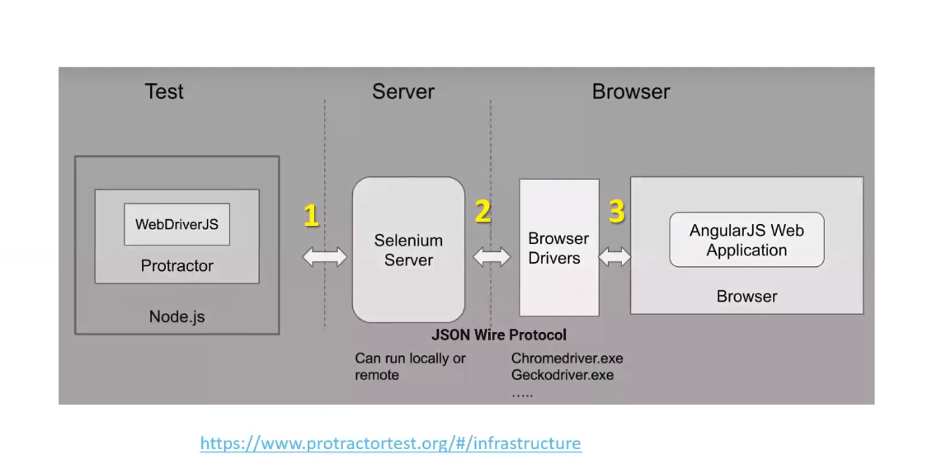 How to install Protractor on Windows?**

**Note:** To install Protractor first we need to install Node.js because protractor is a node.js application.

Once we installed node.js we get npm (npm -v) also. so, we need to add both node.js and npm paths to environmental variables i.e.,

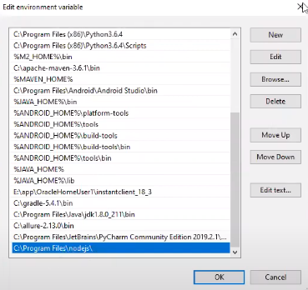

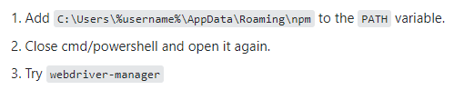

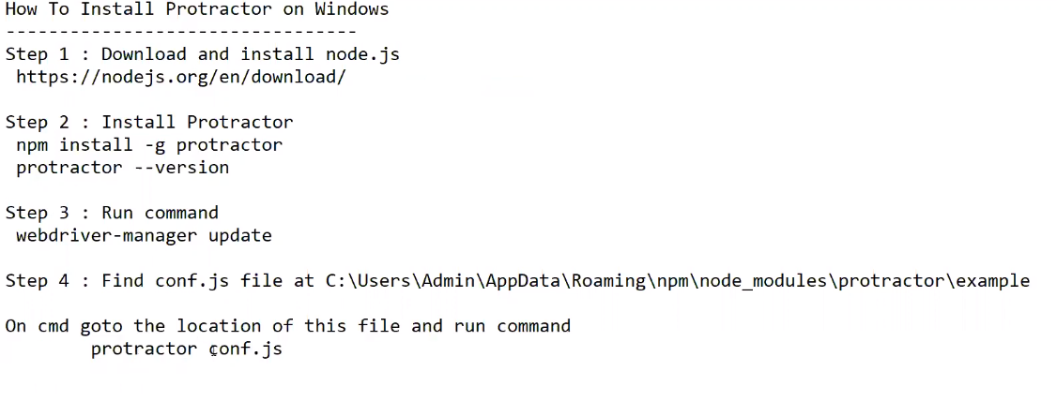

**Steps to Install Jasmine Package:**

we will be using **Jasmine** as test-framework. To install Jasmine globally,  open your command prompt and type:

**npm install -g jasmine**

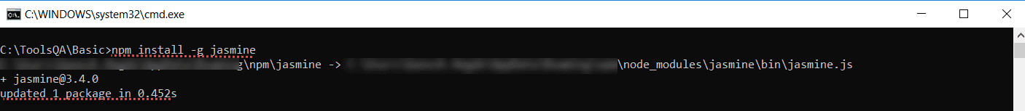

**Note: When -g is used package will be installed globally and can be referenced by any project.**

**How to setup protractor project in visual studio code:** 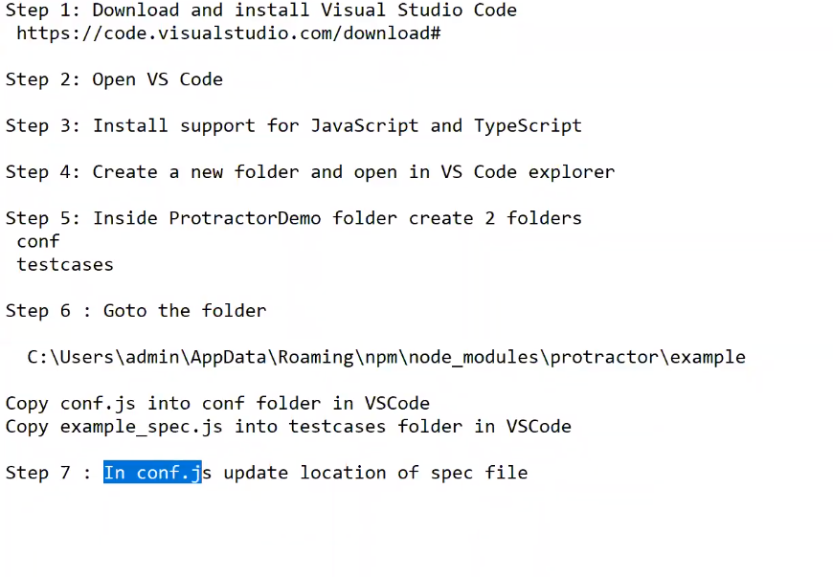 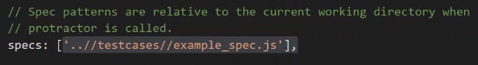 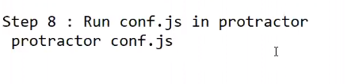

**Writing first test in protractor?**

* By default, Protractor follow Jasmine framework
* Jasmine follows Behavior-Driven JavaScript

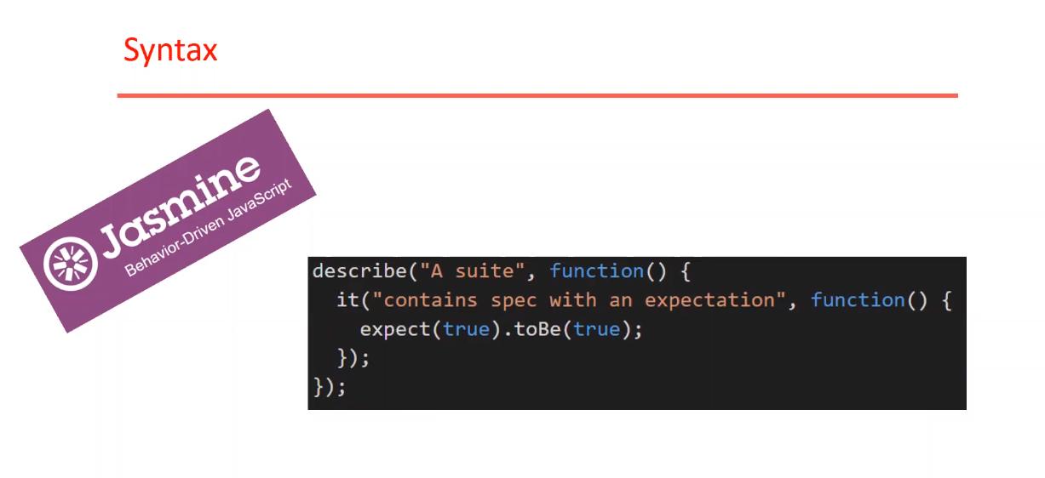

**NOTE:** Please refer “ <https://www.protractortest.org/#/api> “ for complete protraction api’s . 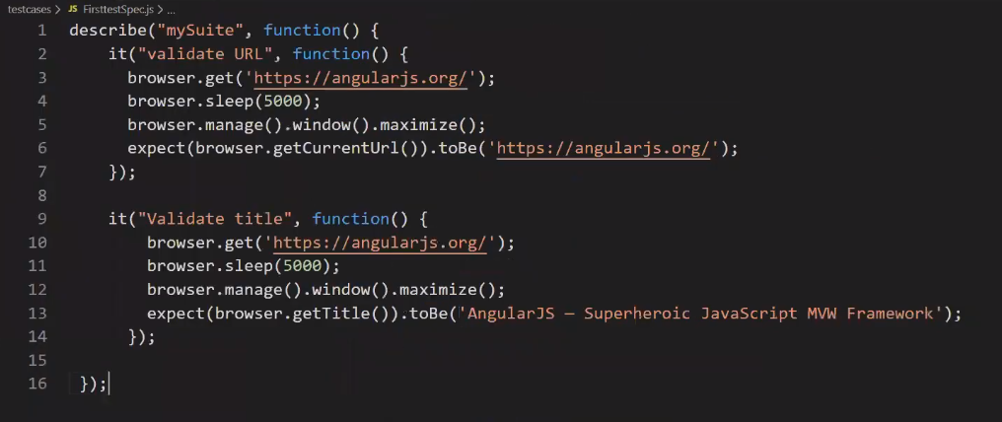

Add the above specs file into to conf.js 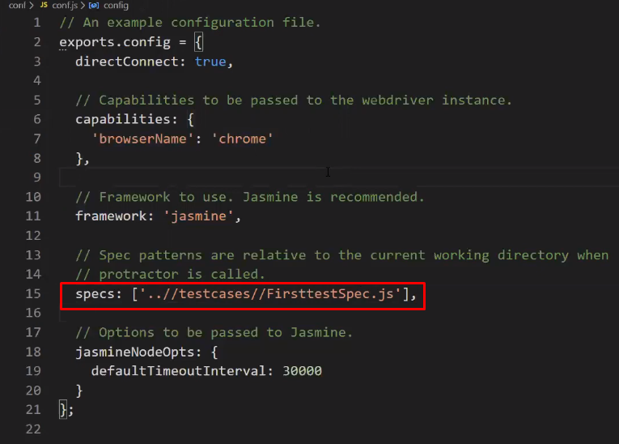

Execute the test case by terminal i.e.,

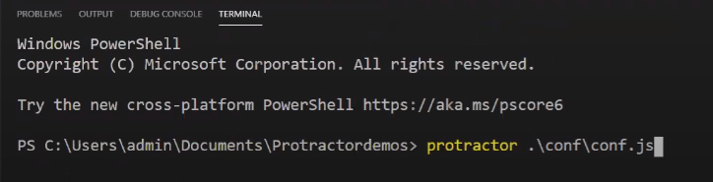

**Locators:** 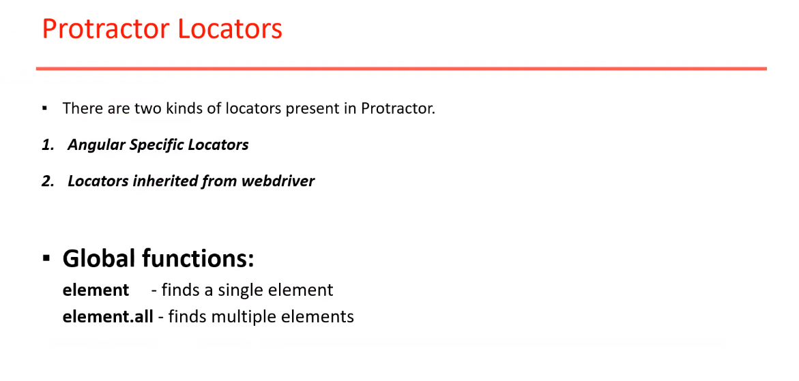 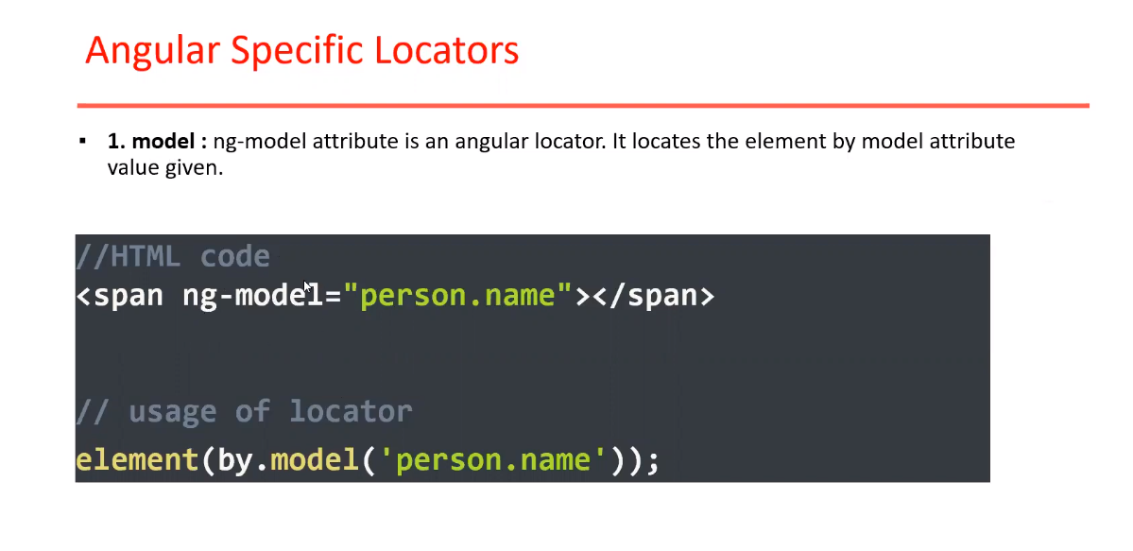 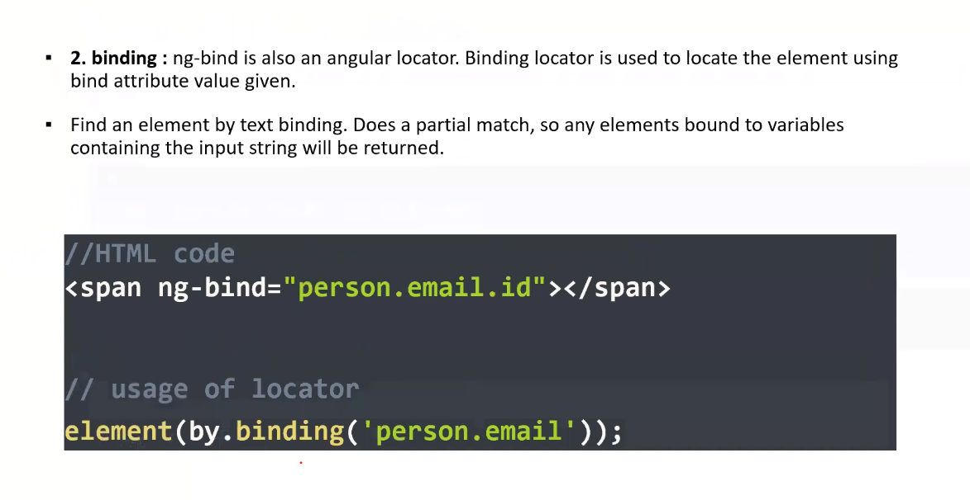 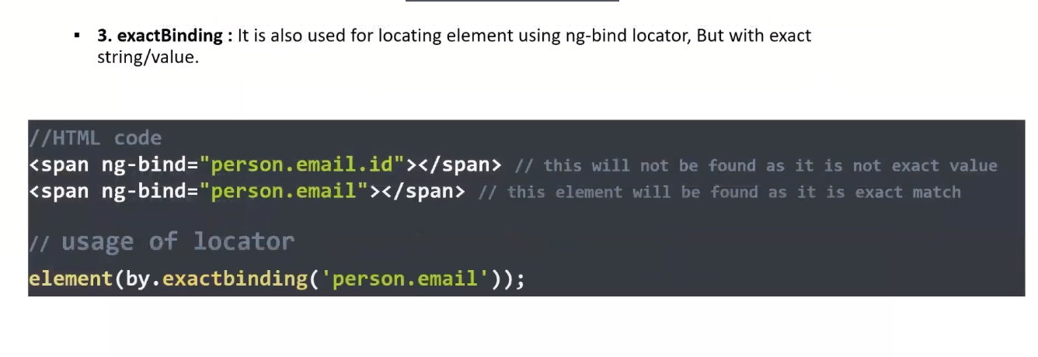 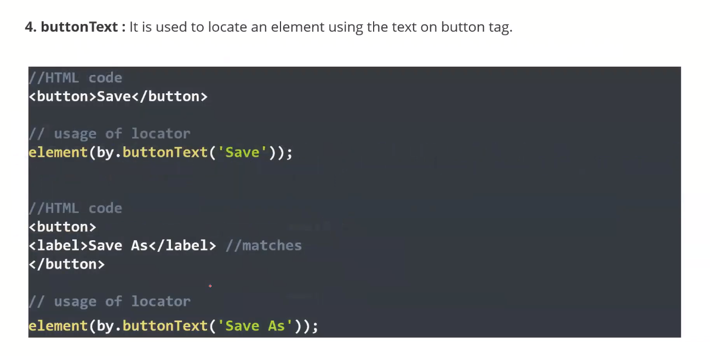 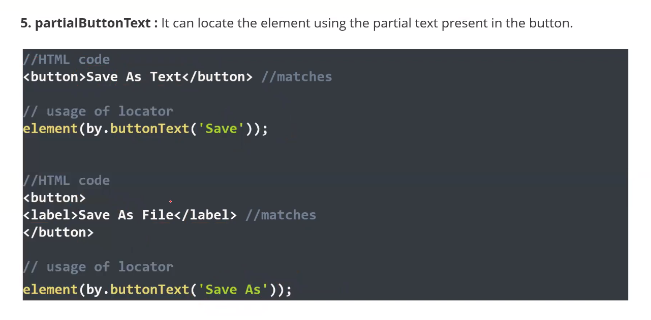 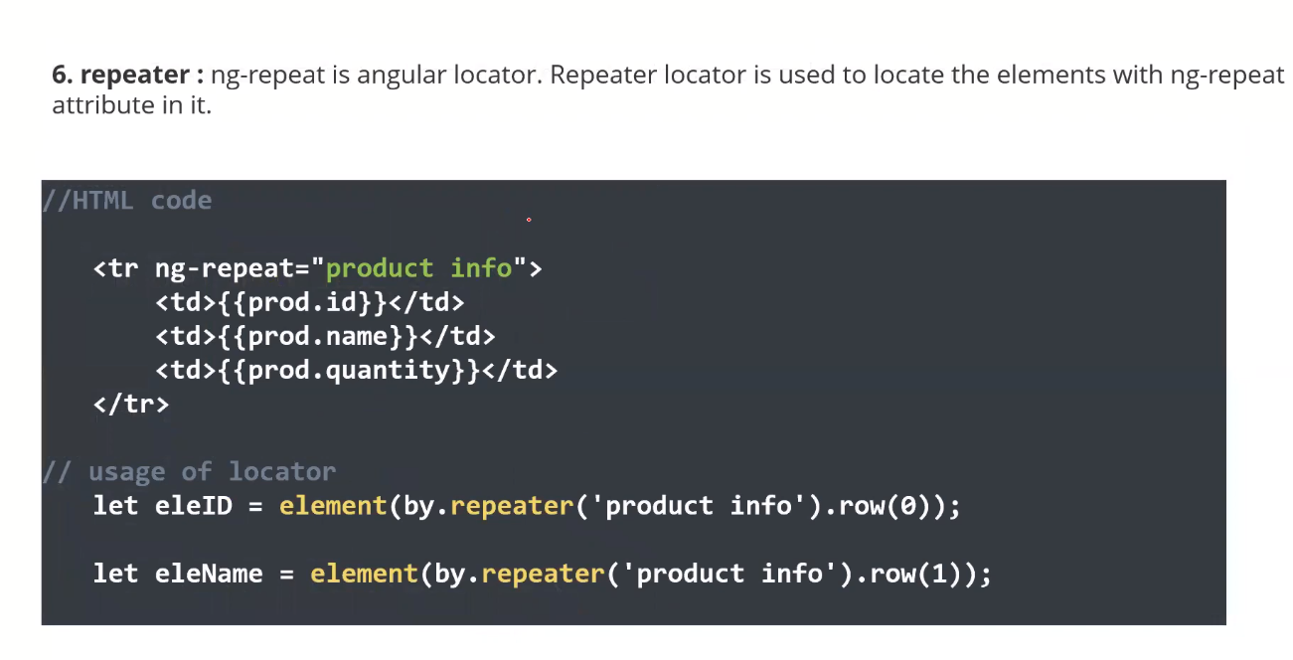 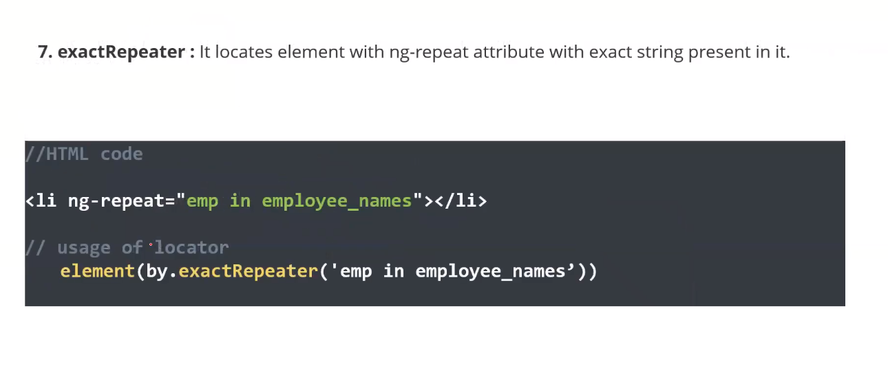 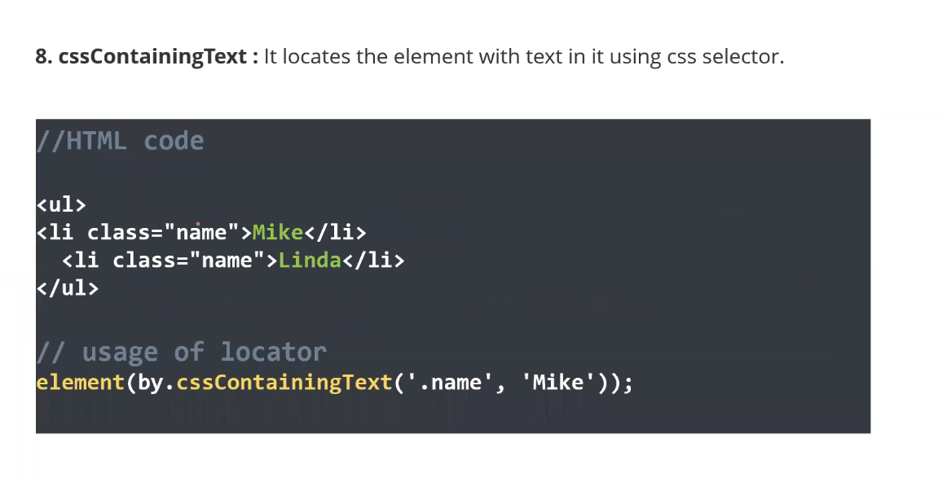 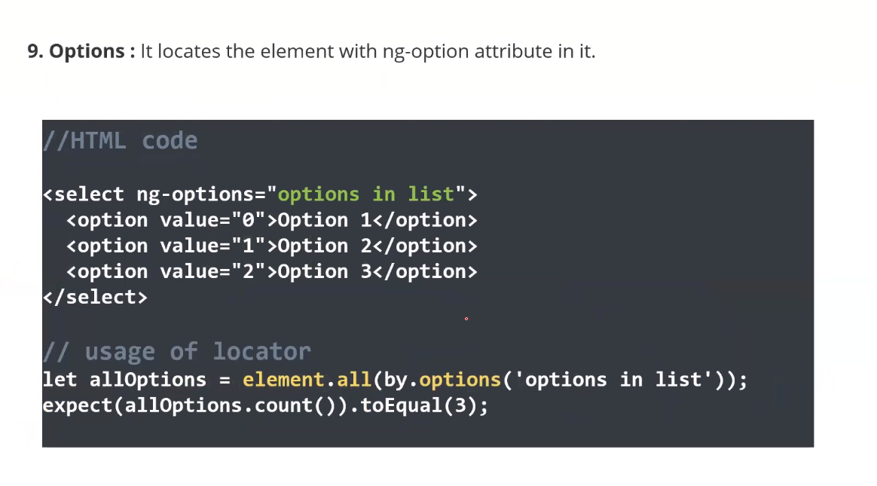 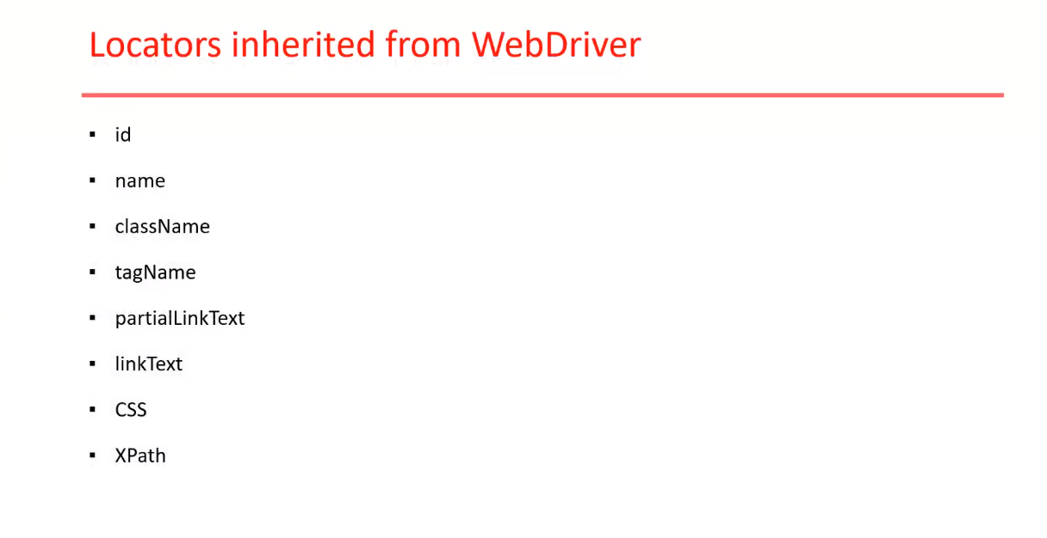 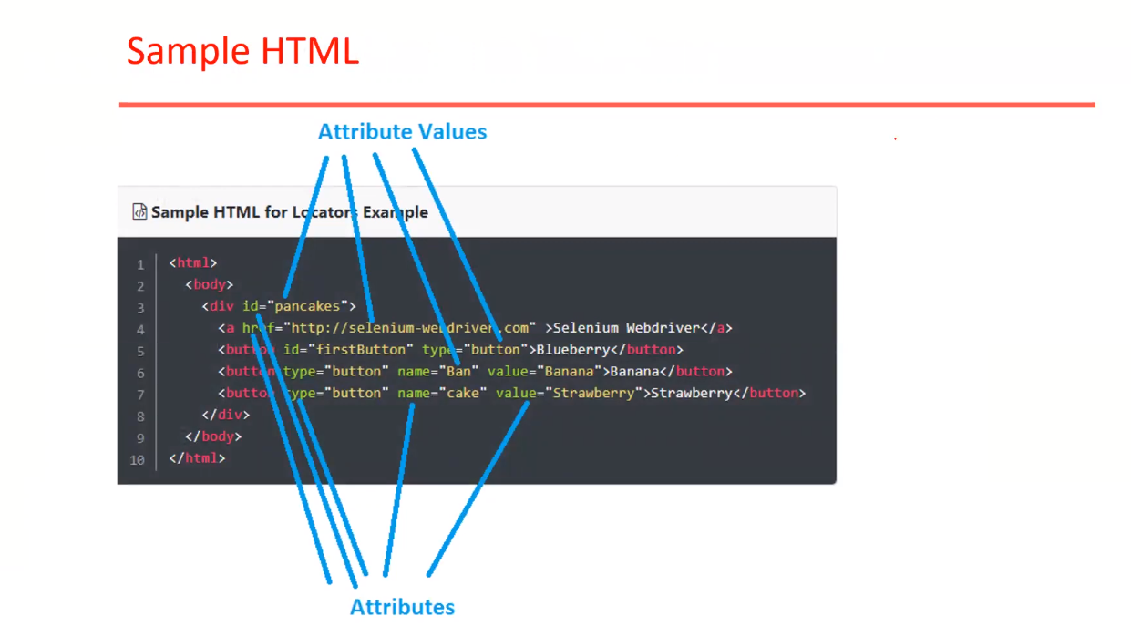 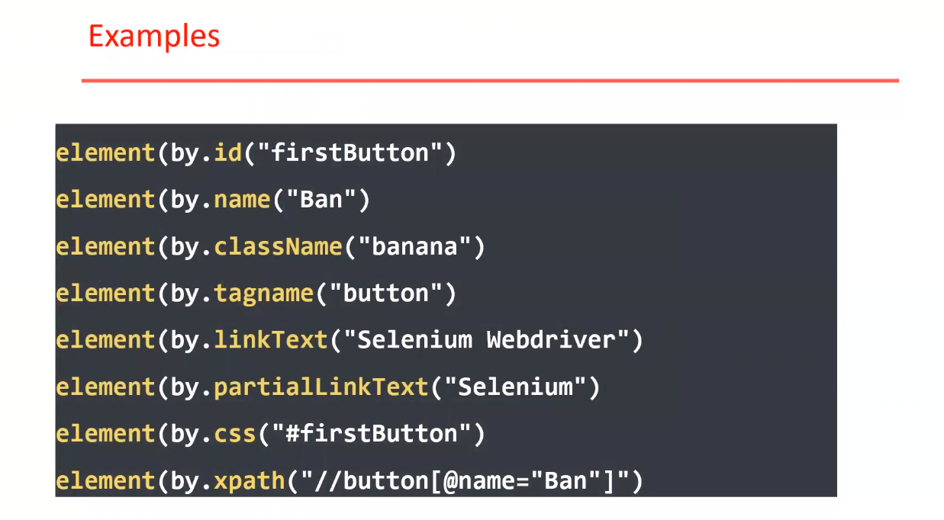

**Jasmine Testing Framework:** 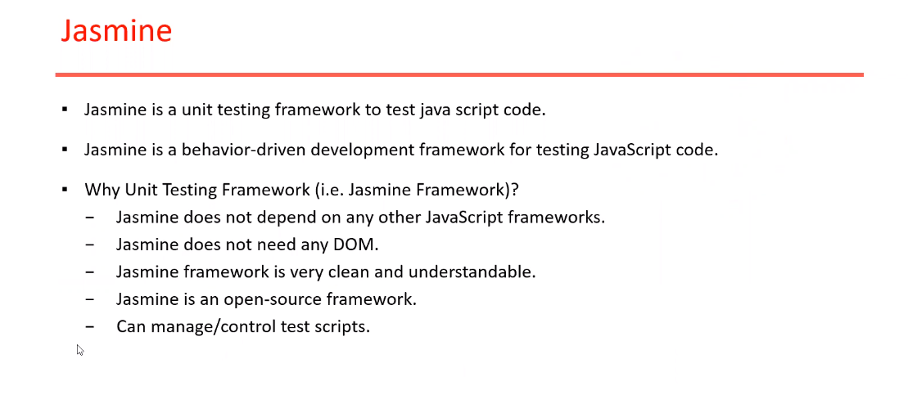 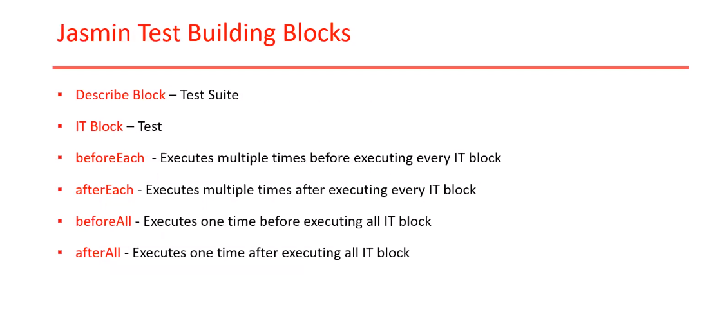 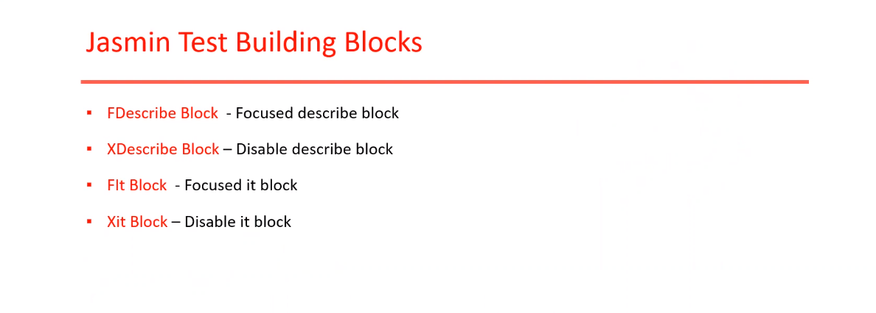 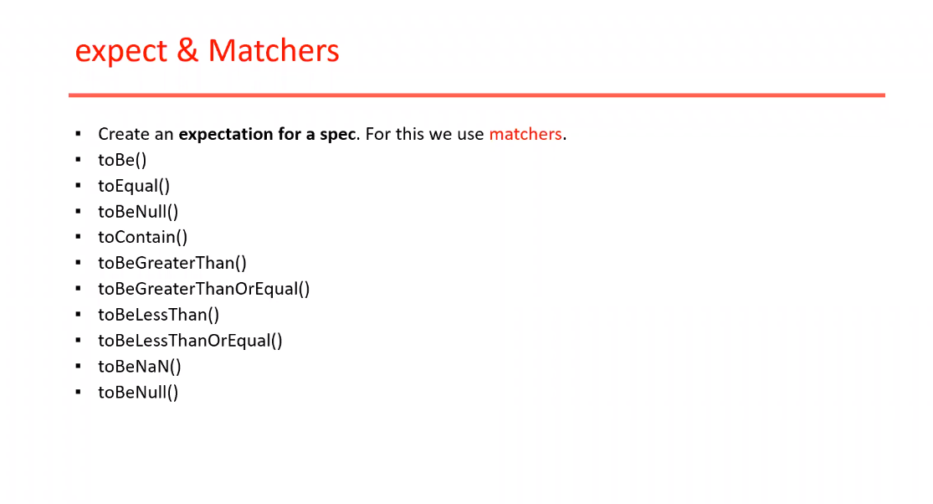

**Crate a Test Case in Protractor :** 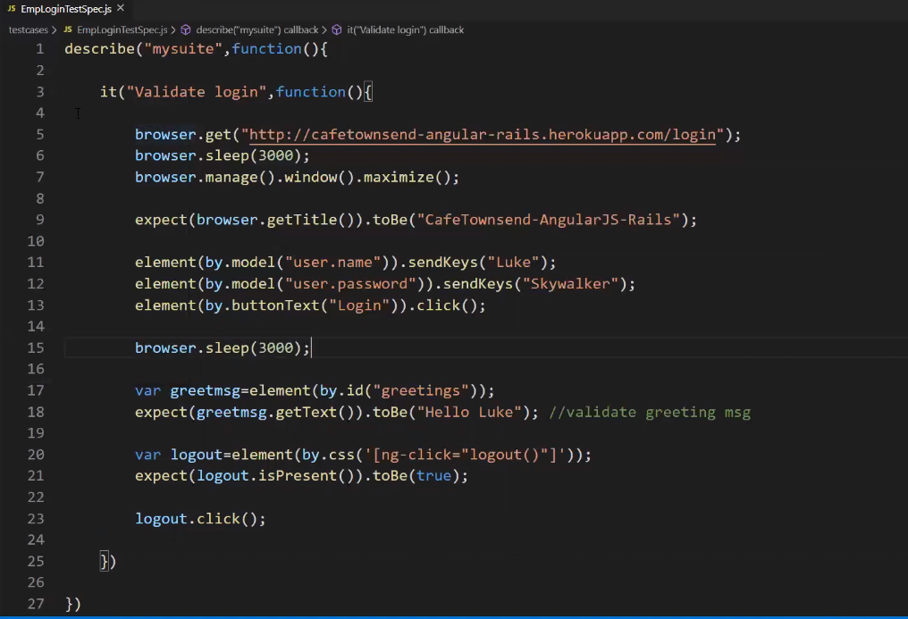

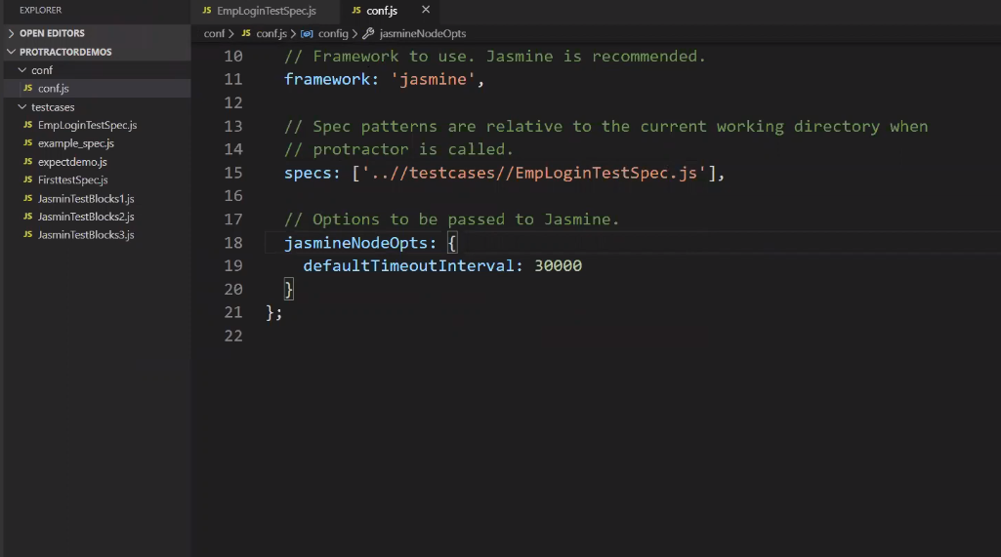

**Elements in Angular JS Application:** 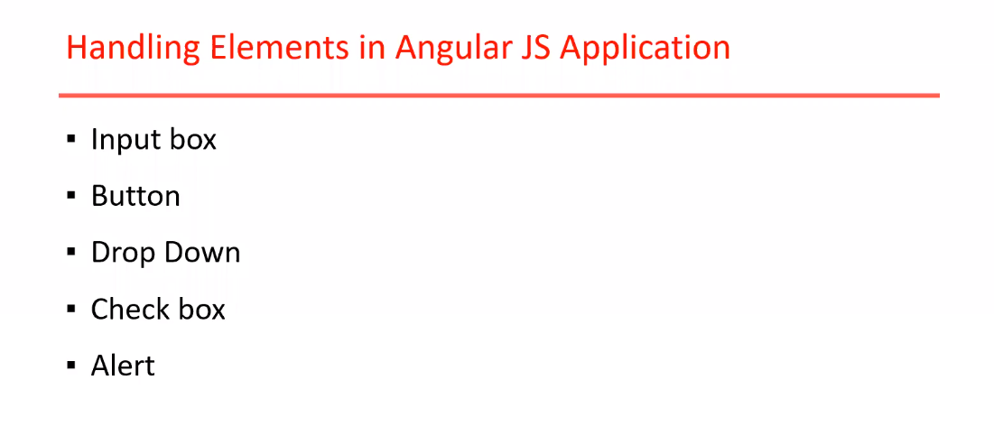 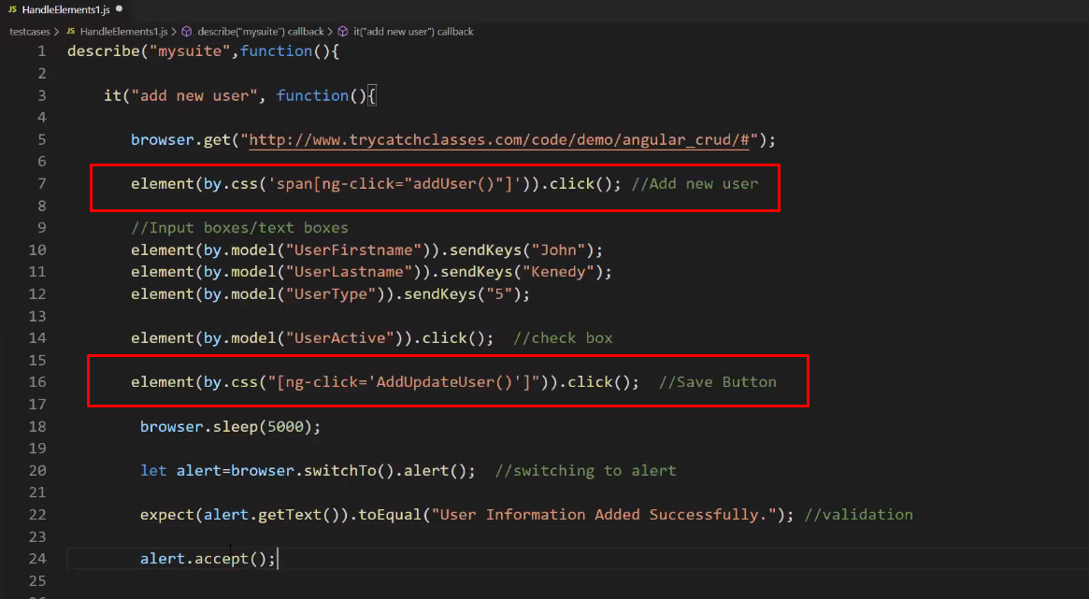 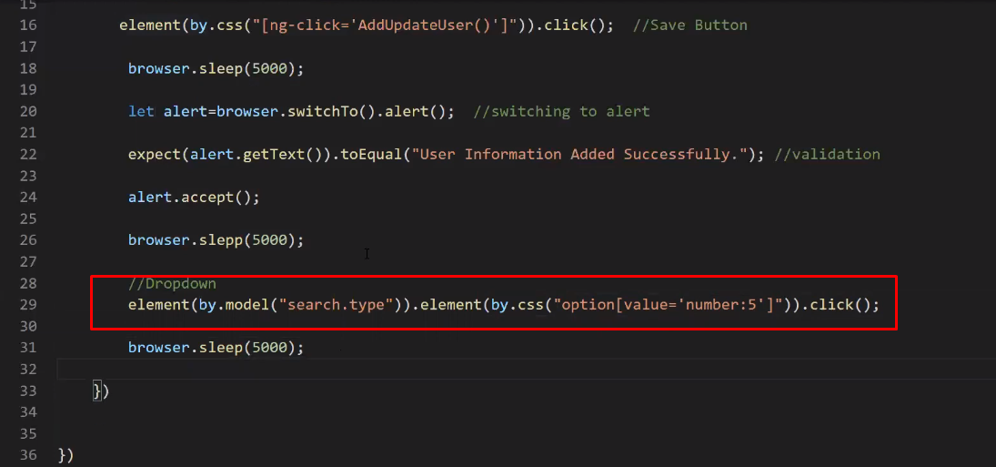

**Working with Table in Protractor:** 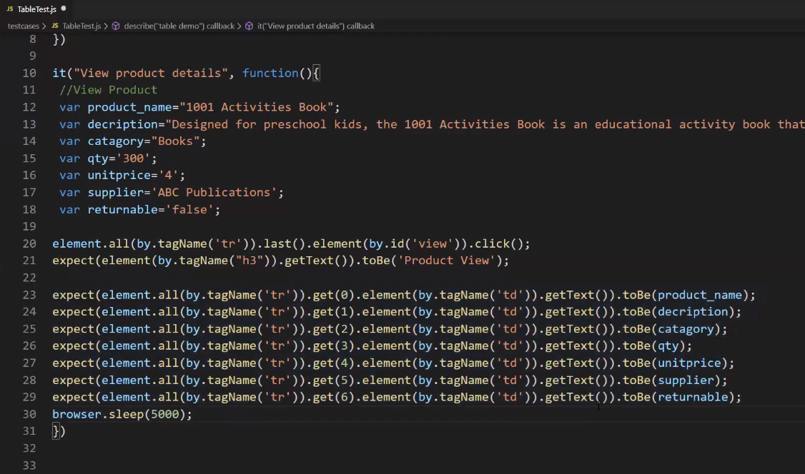

**Automating Non-Angular applications:**

We need to add mandatory any one of below statements to work on non-angular applications.

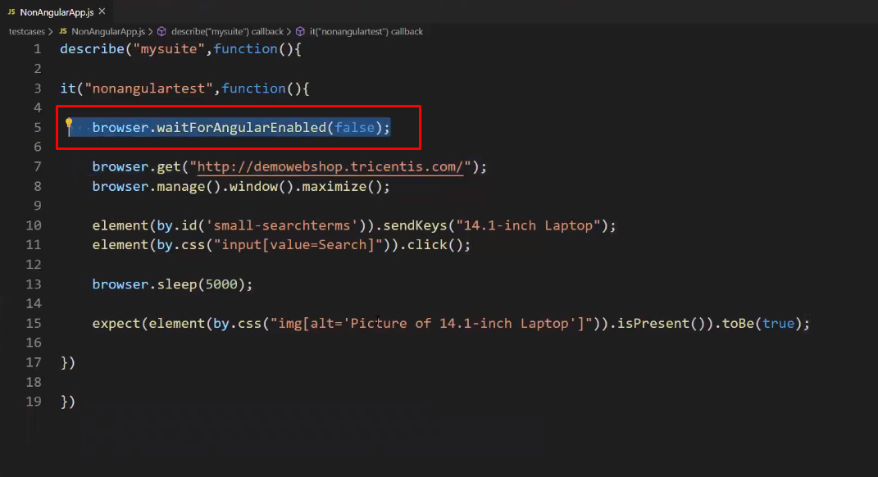

Or

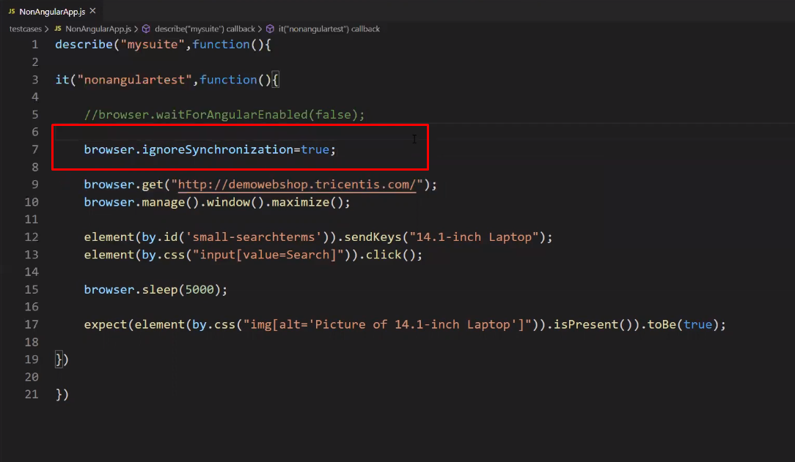

**Handling Frames in Protractor:** 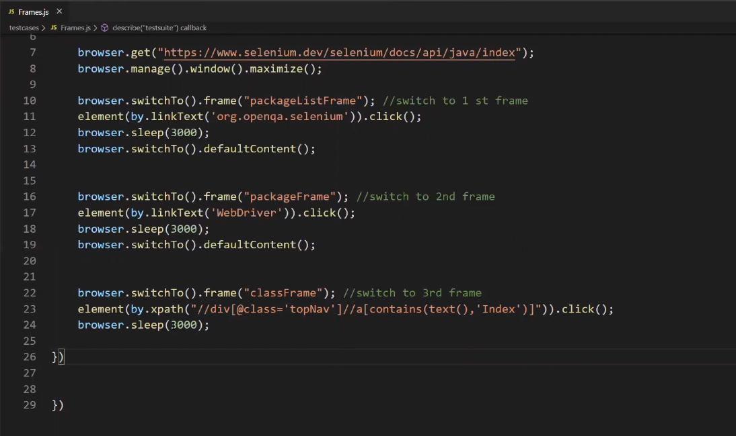

**Mouse Actions:** 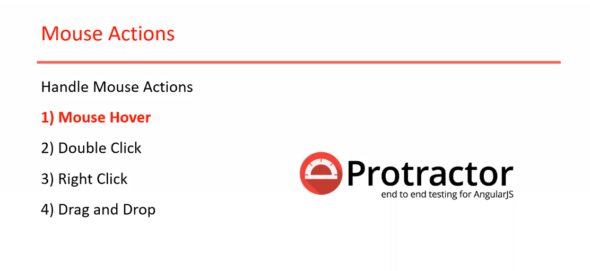 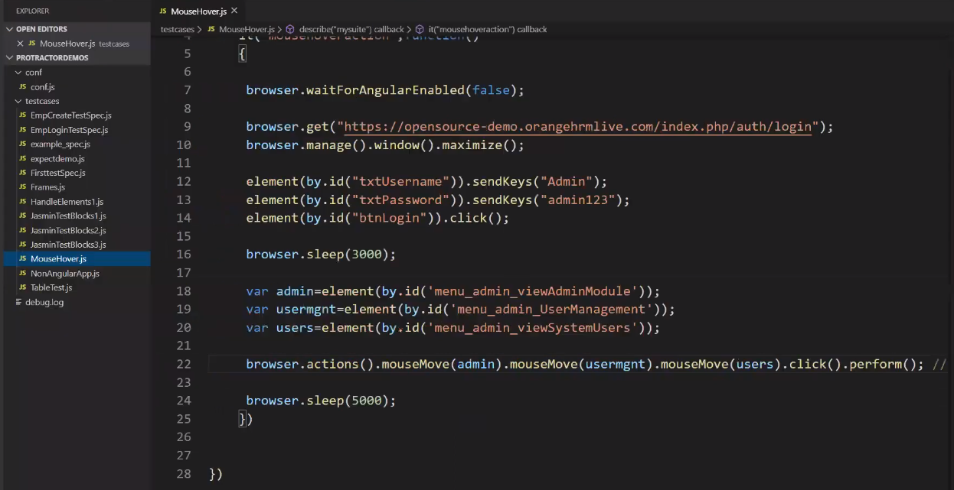

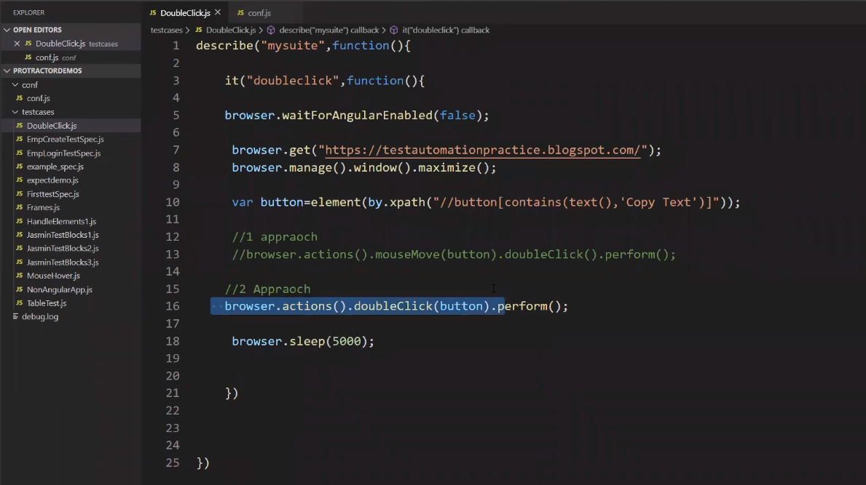 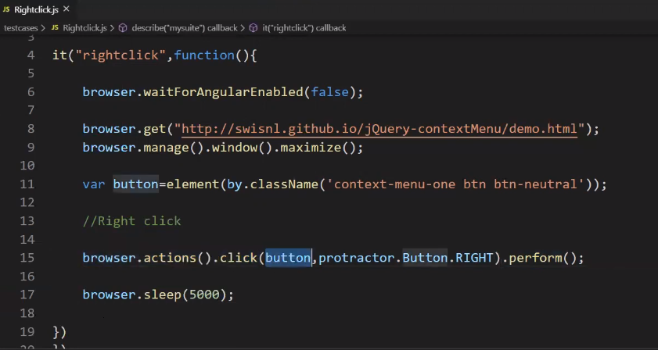 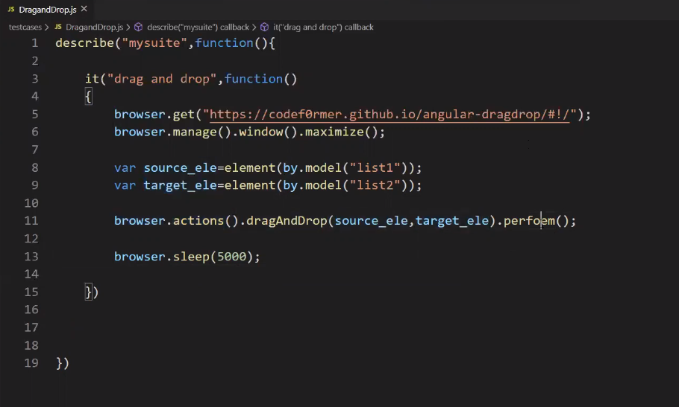

**Page Object Model :** 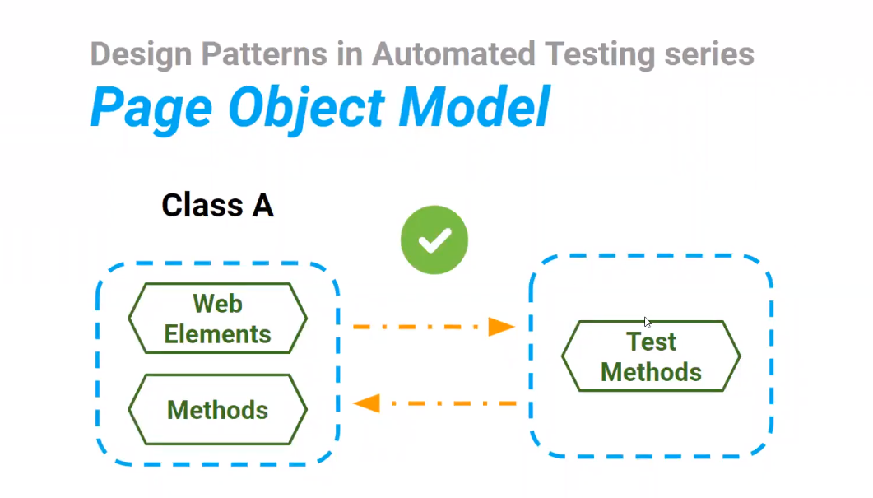

**Refer** : <https://www.youtube.com/watch?v=t-jztd8xKag&list=PLUDwpEzHYYLt9nBh8fMrJMt2PCHnWCqN1&index=19>

**HTML Reports with screenshots:**

**Refer :** [**https://www.npmjs.com/package/protractor-beautiful-reporter**](https://www.npmjs.com/package/protractor-beautiful-reporter)

First, we need install protractor-beautiful-reporter in protractor folder i.e.,



npm install protractor-beautiful-reporter --save-dev

